Bank Database – JOIN Queries

1. Display branch ID, name, and the name of the employee who manages it.
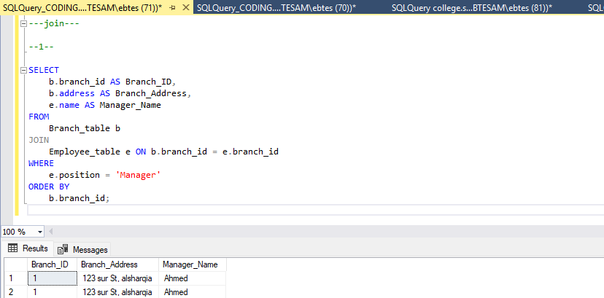
2. Display branch names and the accounts opened under each.
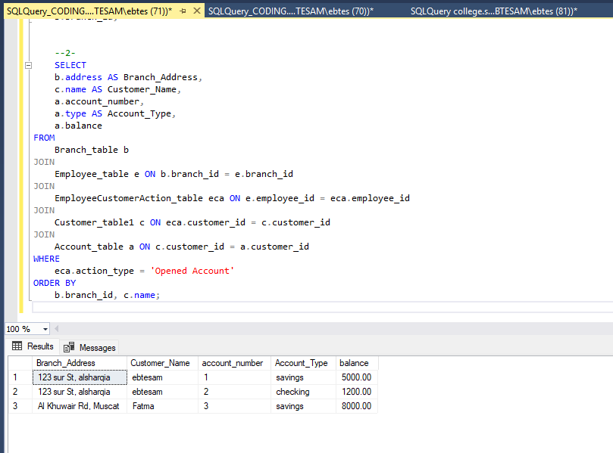
3. Display full customer details along with their loans.

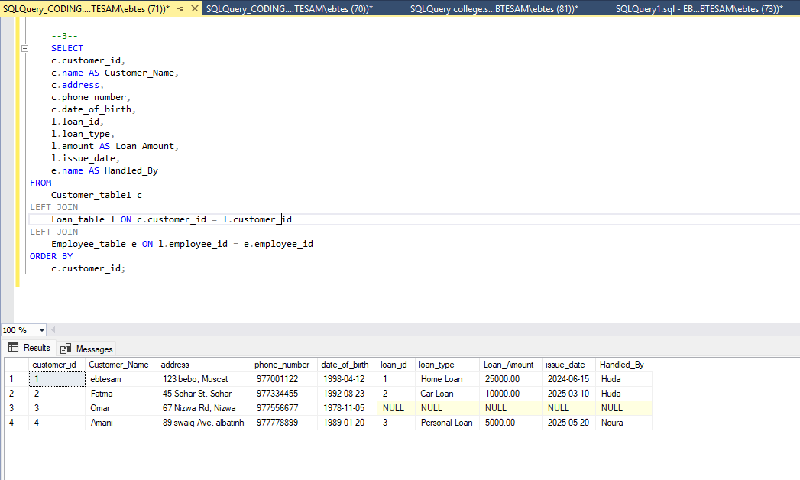
4. Display loan records where the loan office is in 'Alexandria' or 'Giza'.
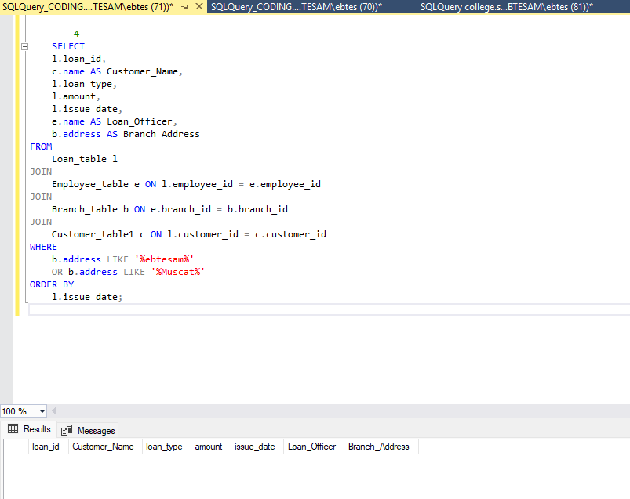

5. Display account data where the type starts with "S" (e.g., "Savings").
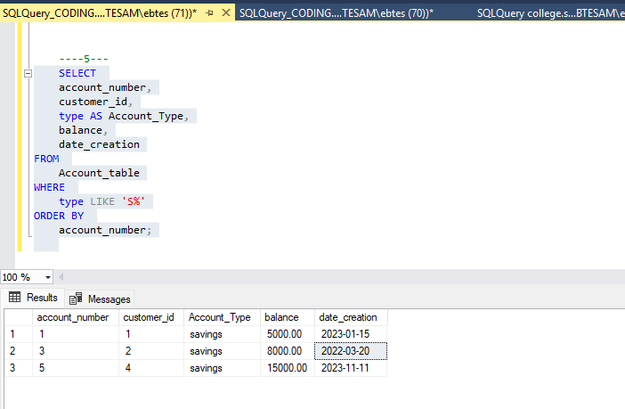
6. List customers with accounts having balances between 20,000 and 50,000.
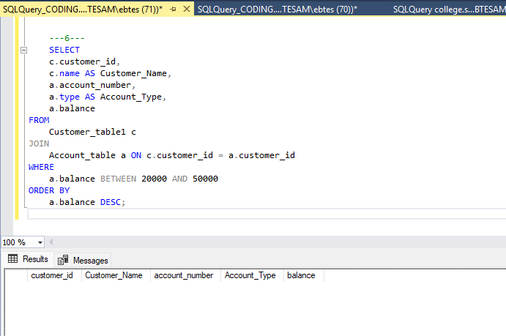

7. Retrieve customer names who borrowed more than 100,000 LE from 'Cairo Main Branch'.
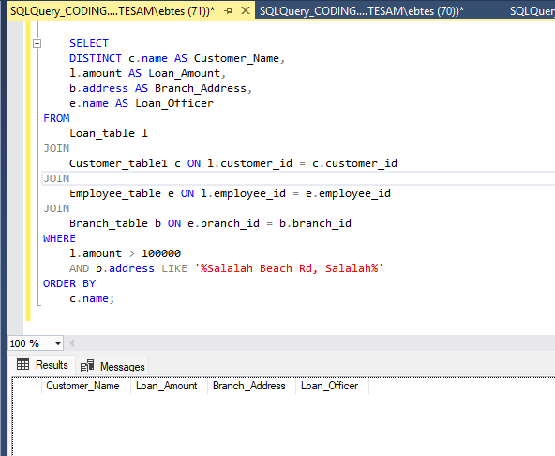
8. Find all customers assisted by employee "Amira Khaled".
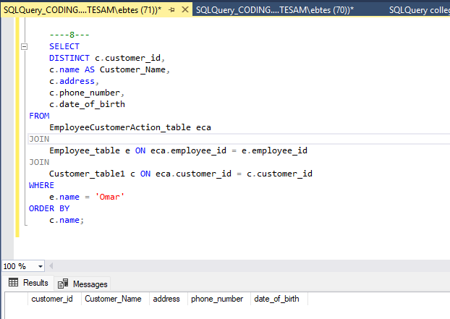
9. Display each customer’s name and the accounts they hold, sorted by account type.
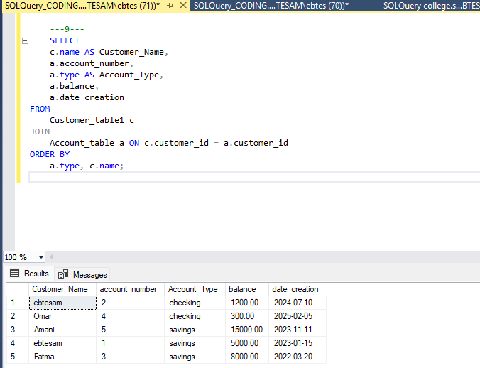
10. For each loan issued in Cairo, show loan ID, customer name, employee handling it, and branch name.
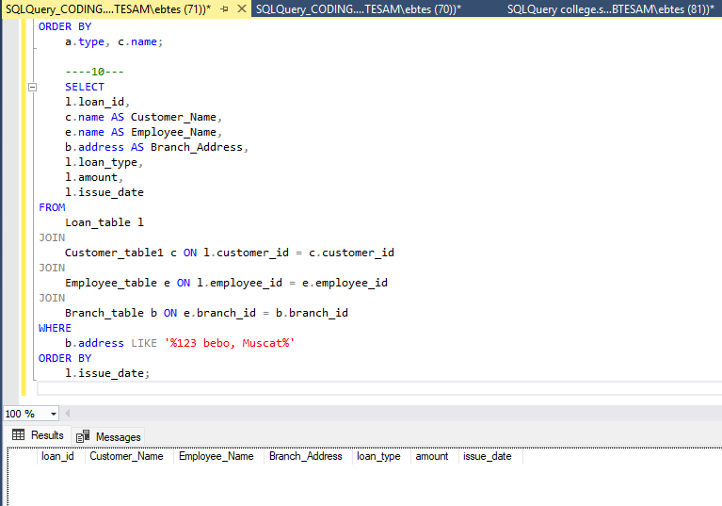
11. Display all employees who manage any branch.
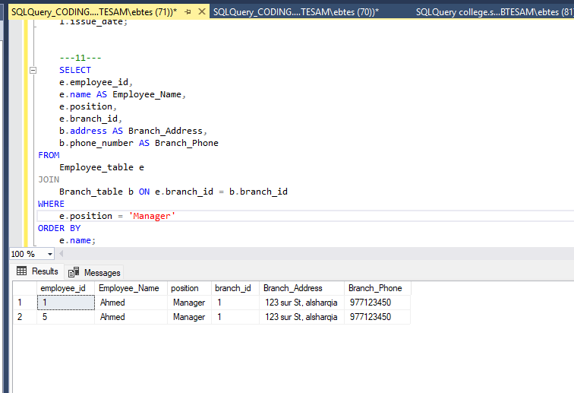
12. Display all customers and their transactions, even if some customers have no transactions yet.
